ASSIGNMENT

Objective:

Design an application for student management system

Problem Statement:

A popular education society "EduExcellence" is setting up a new school in the city. They want a "School Management Software" that should match the high standards of the school that they aspire to build. They have hired you to provide them with the software that should enable them to manage all aspects of running a school successfully, but they would want the application to grow gradually with the growth of the new school.

Assignment:

Use relevant microservice design patterns in your previous

implementation:

1. Service registry/discovery

2. Client - side load balancing,

3. API Gateway

SOLUTION:

Eureka Server is used for service registry and service discovery.

API Gateway is implemented to route the requests.

Eureka Server runs at port : 8080

API Gateway runs at port: 8989

Student Management Service runs at port: 8084

Fee Management Service runs at port: 8083

SCREENSHOTS:

1. Students available in database TABLE STUDENT.

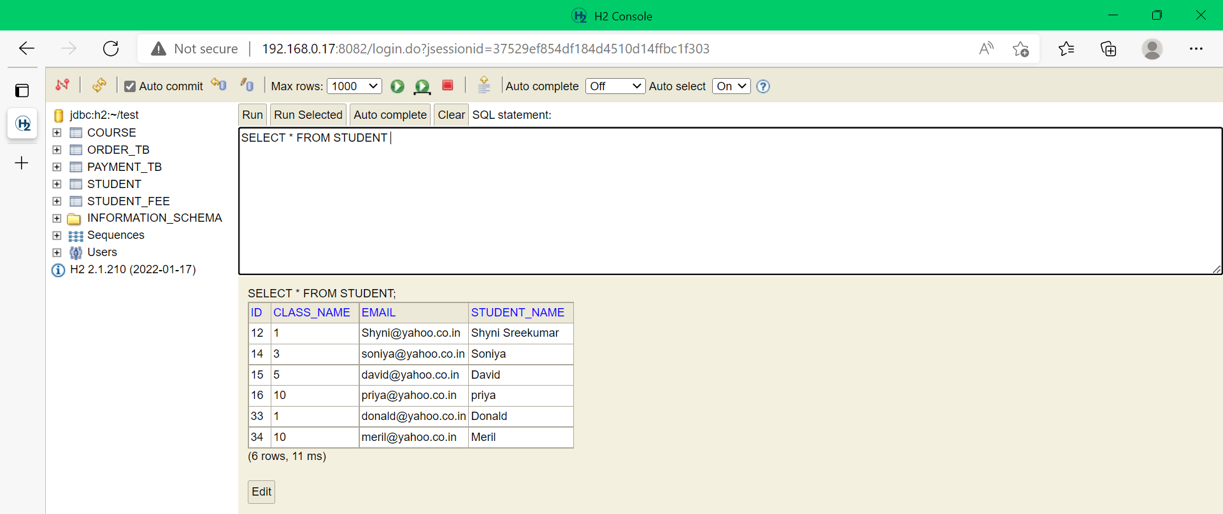

1. Fees of the students available in FEE Table

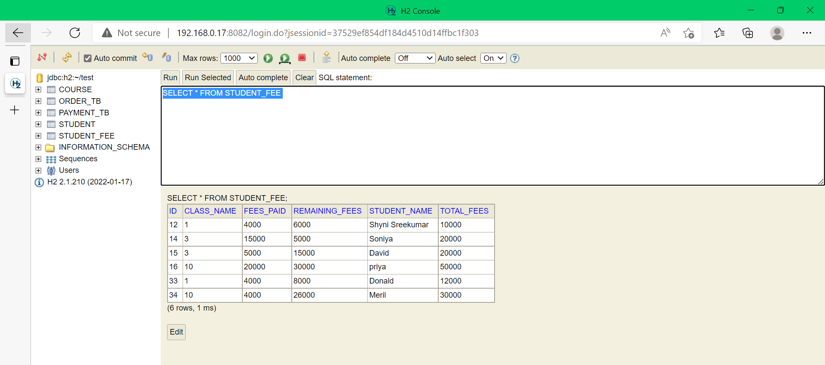

1. Service Registry and Discovery implemented using Eureka server.

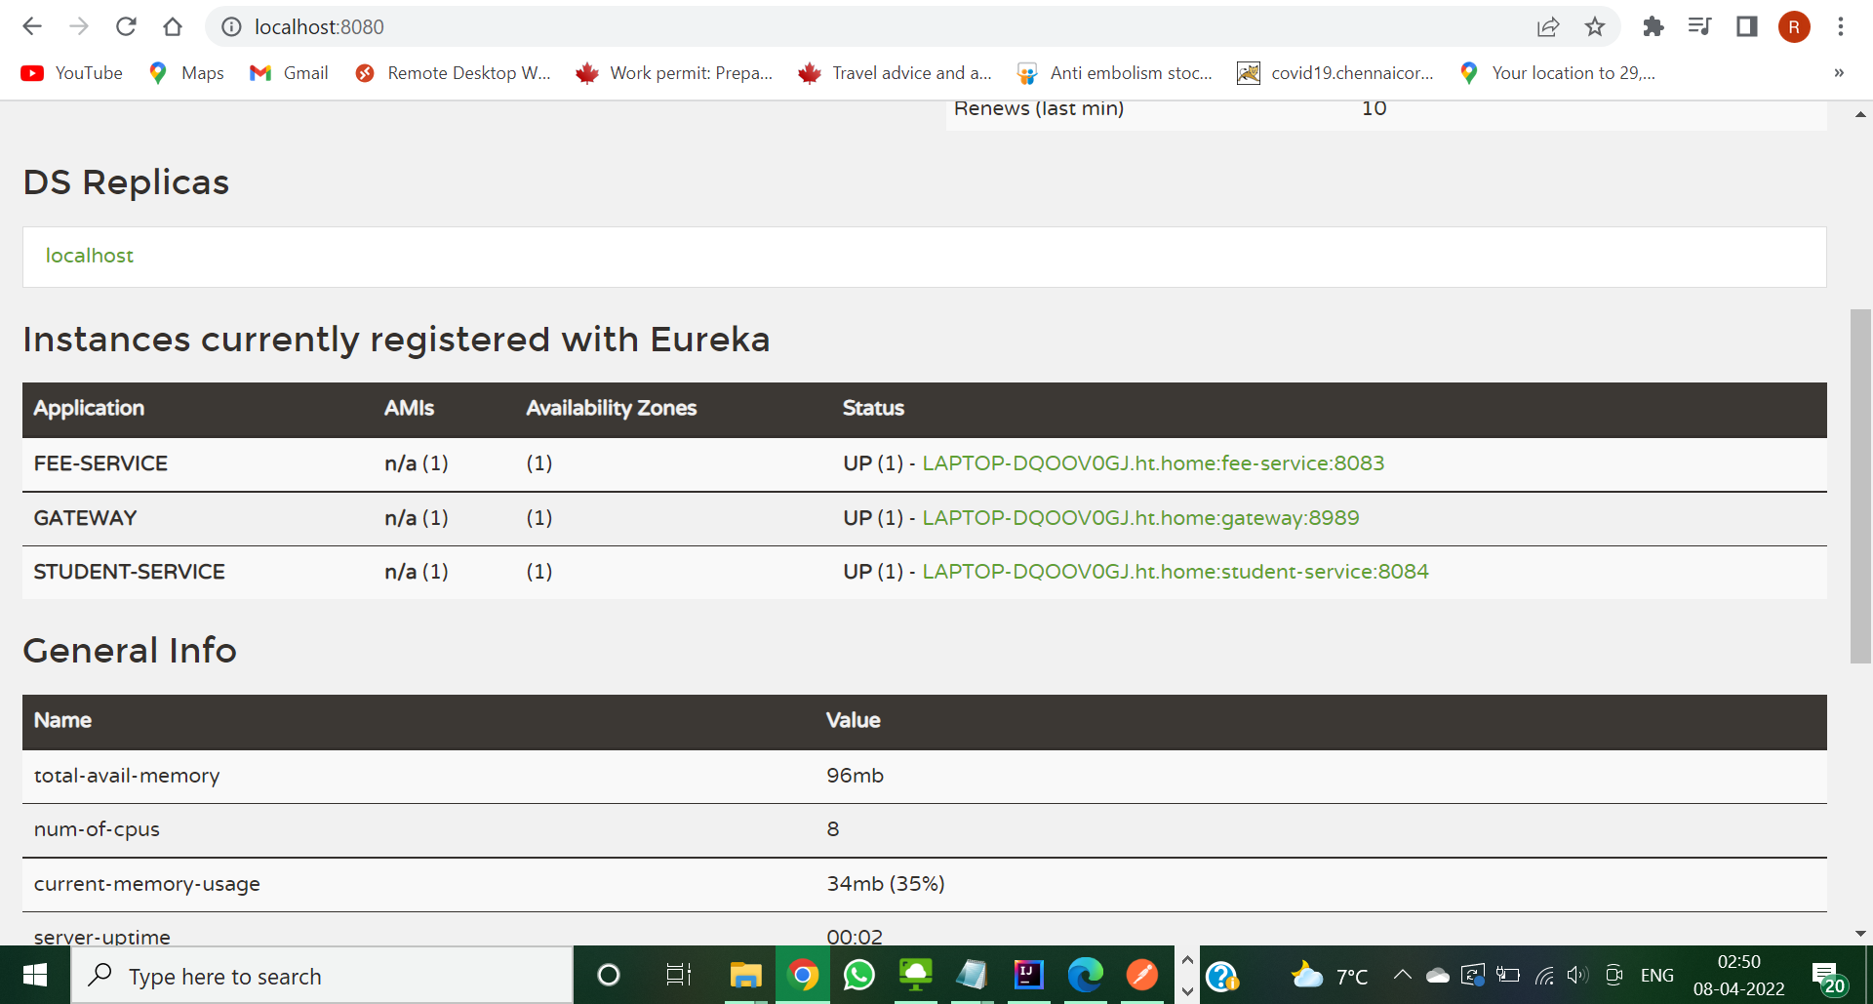

Above screenshot shows the services , student management service and fee management service and api gateway registered to the eureka server.

1. Screenshot showing Eureka Server Registering:

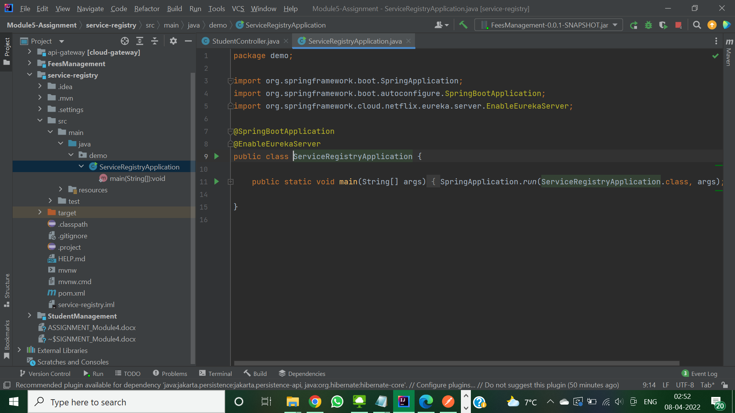

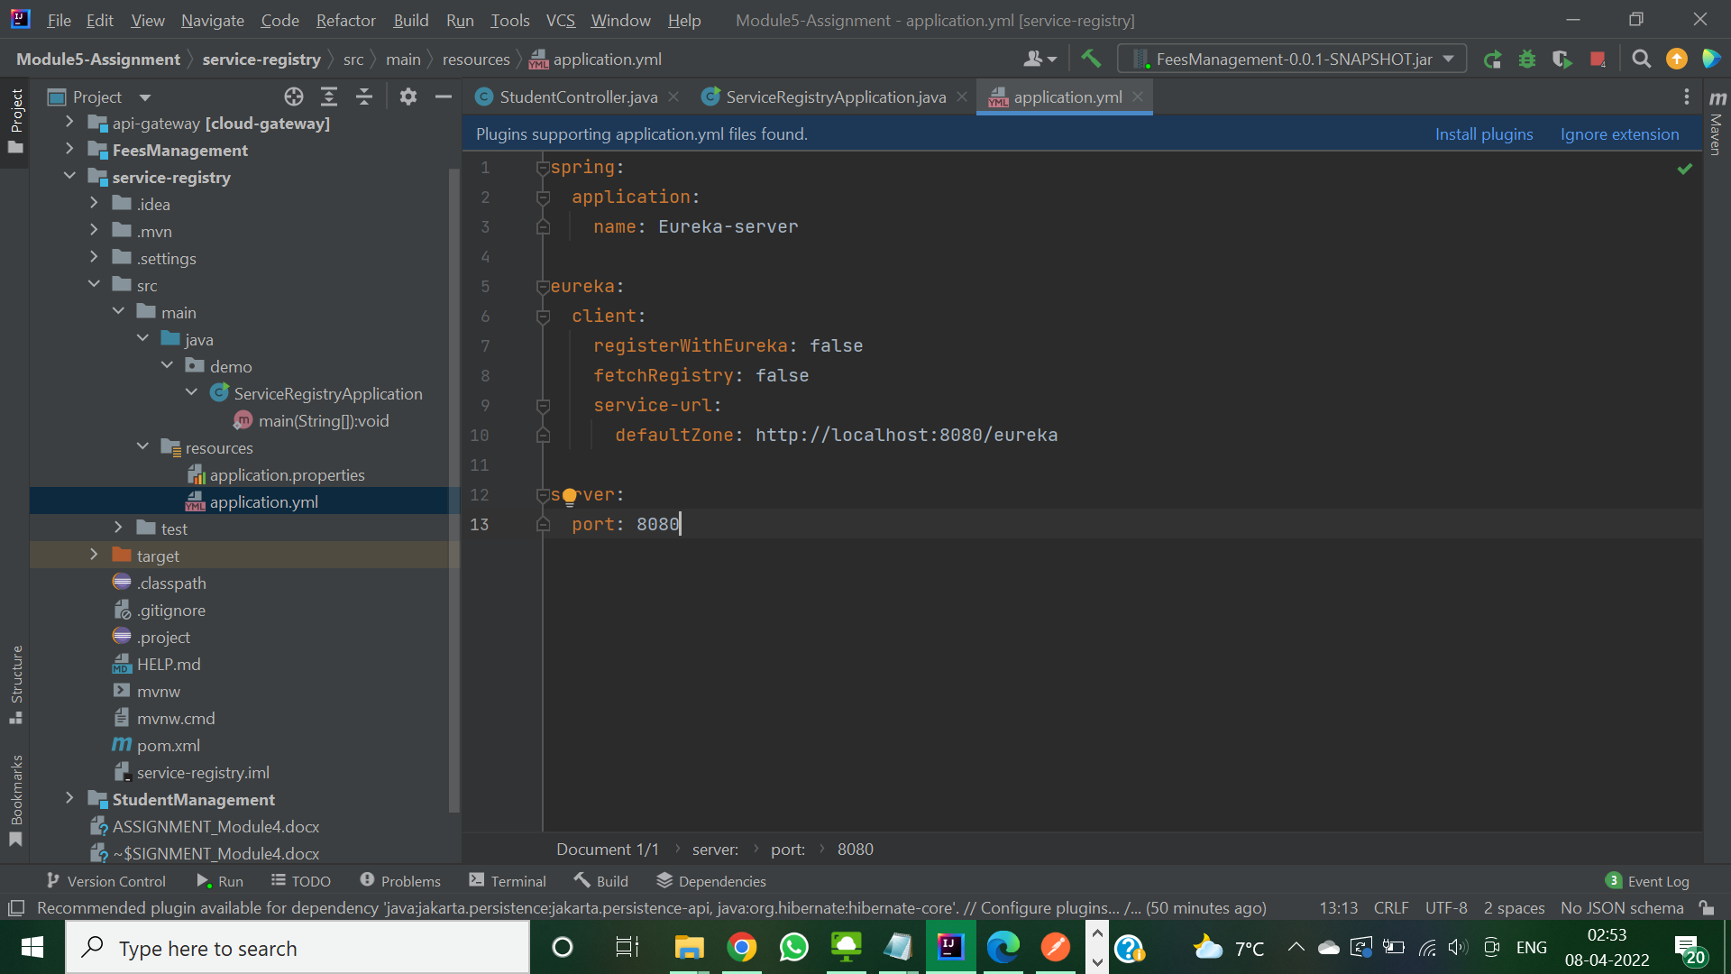

1. Screenshot showing API Gateway registering with eureka server:

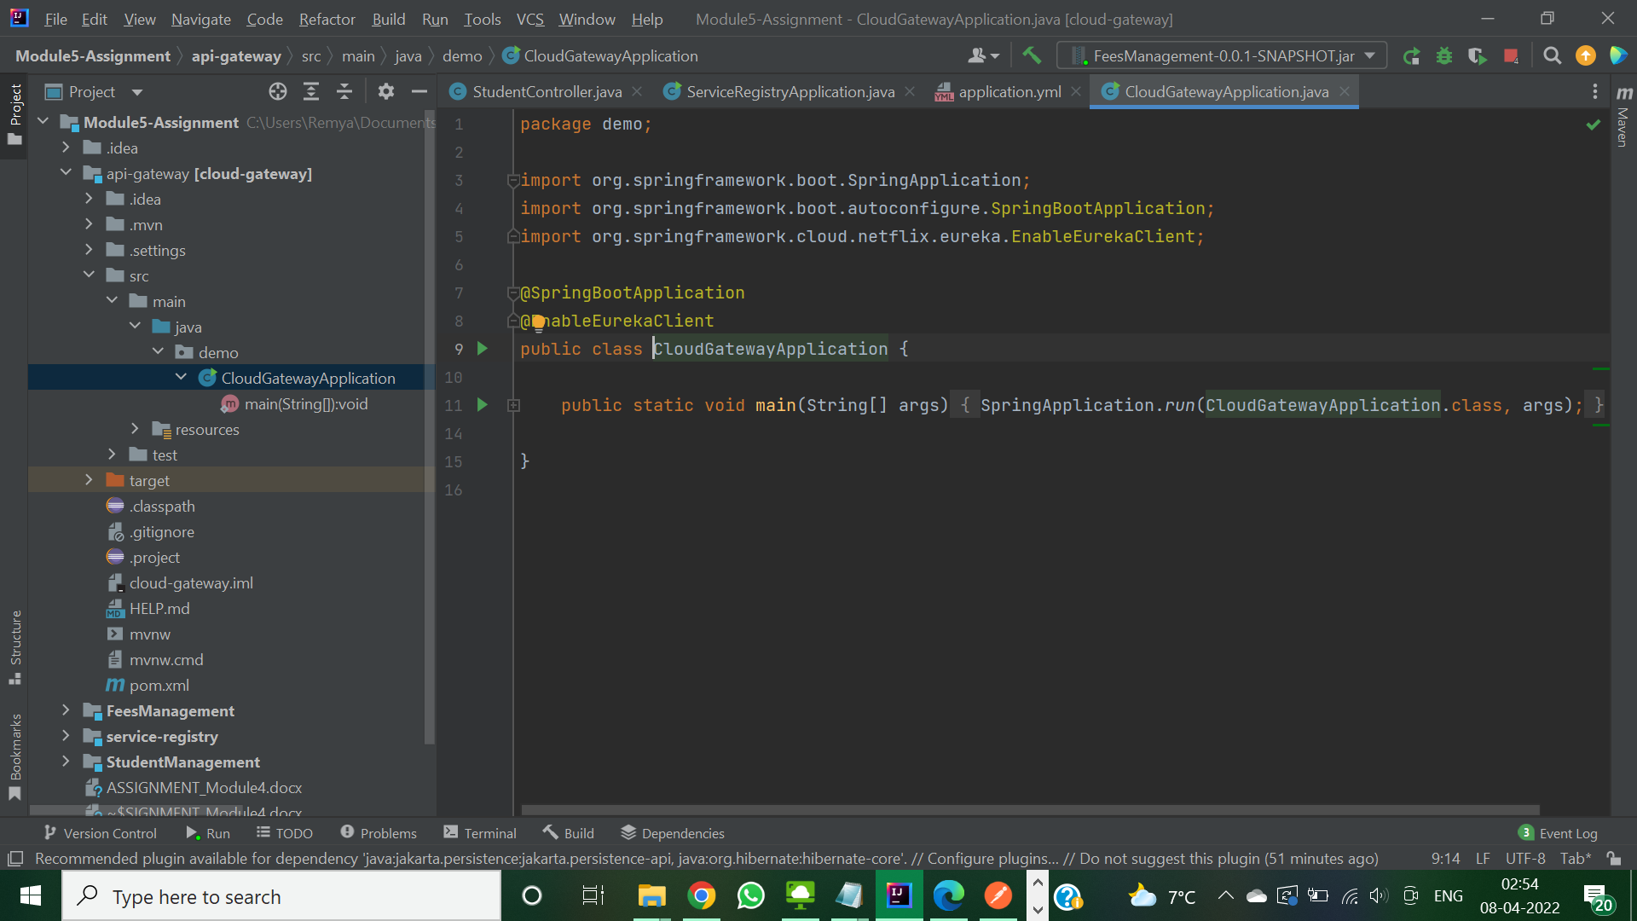

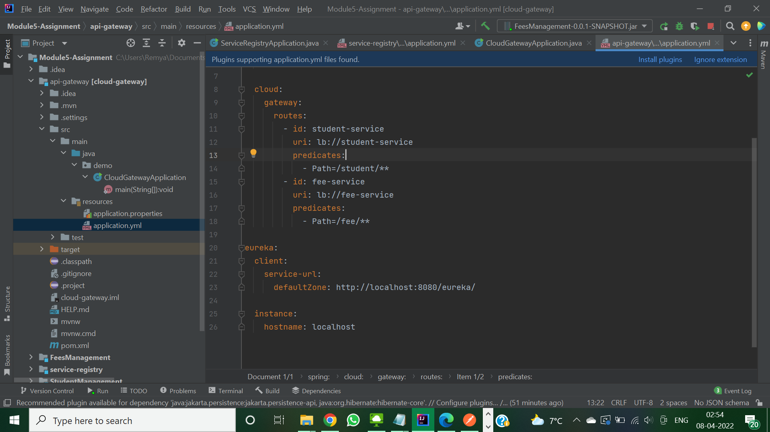

1. Screenshot showing Student management service registering with eureka server

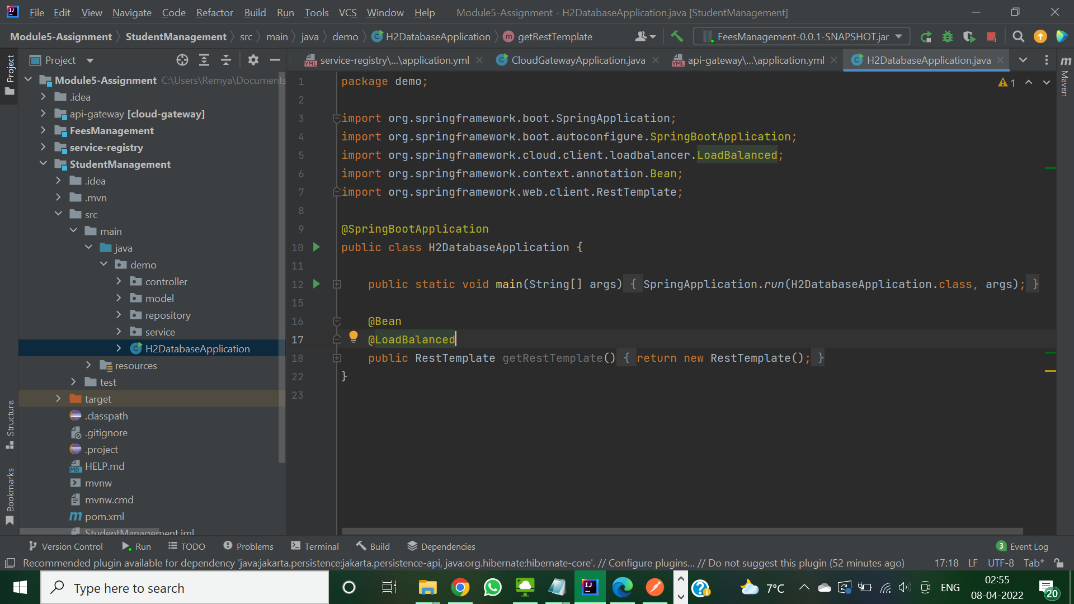

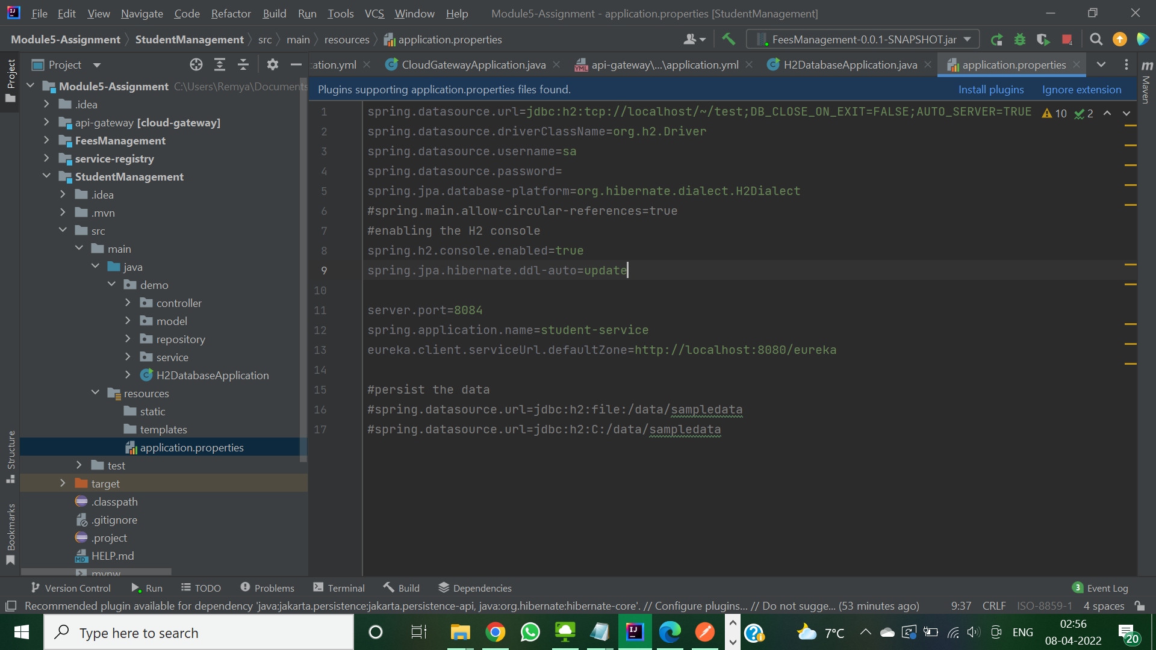

1. Screenshot showing Fee management service registering with eureka server.

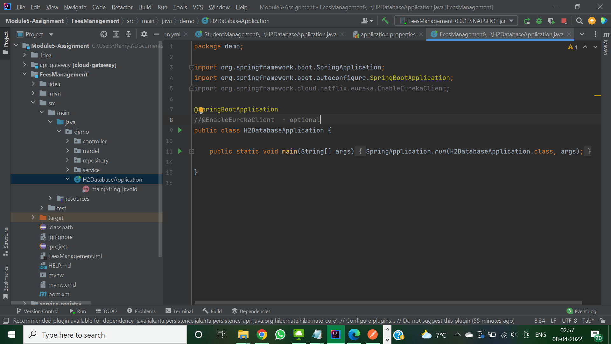

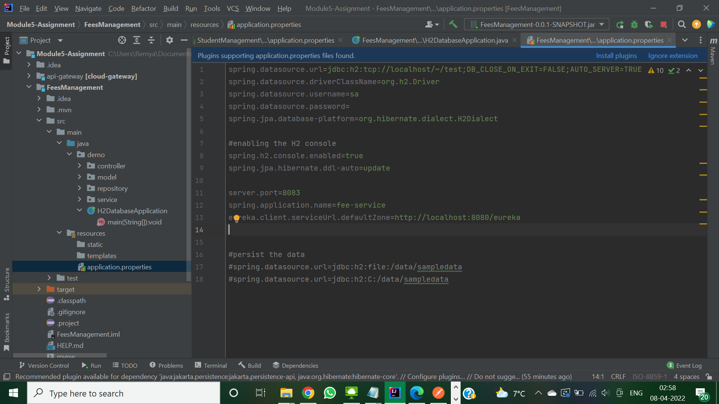

1. Using PostMan accessing the student management service end point via apigateway url.

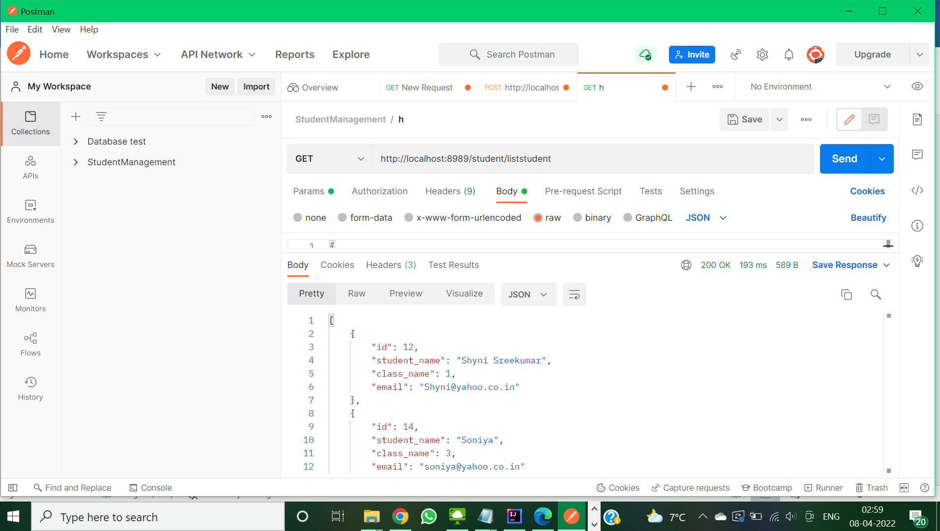

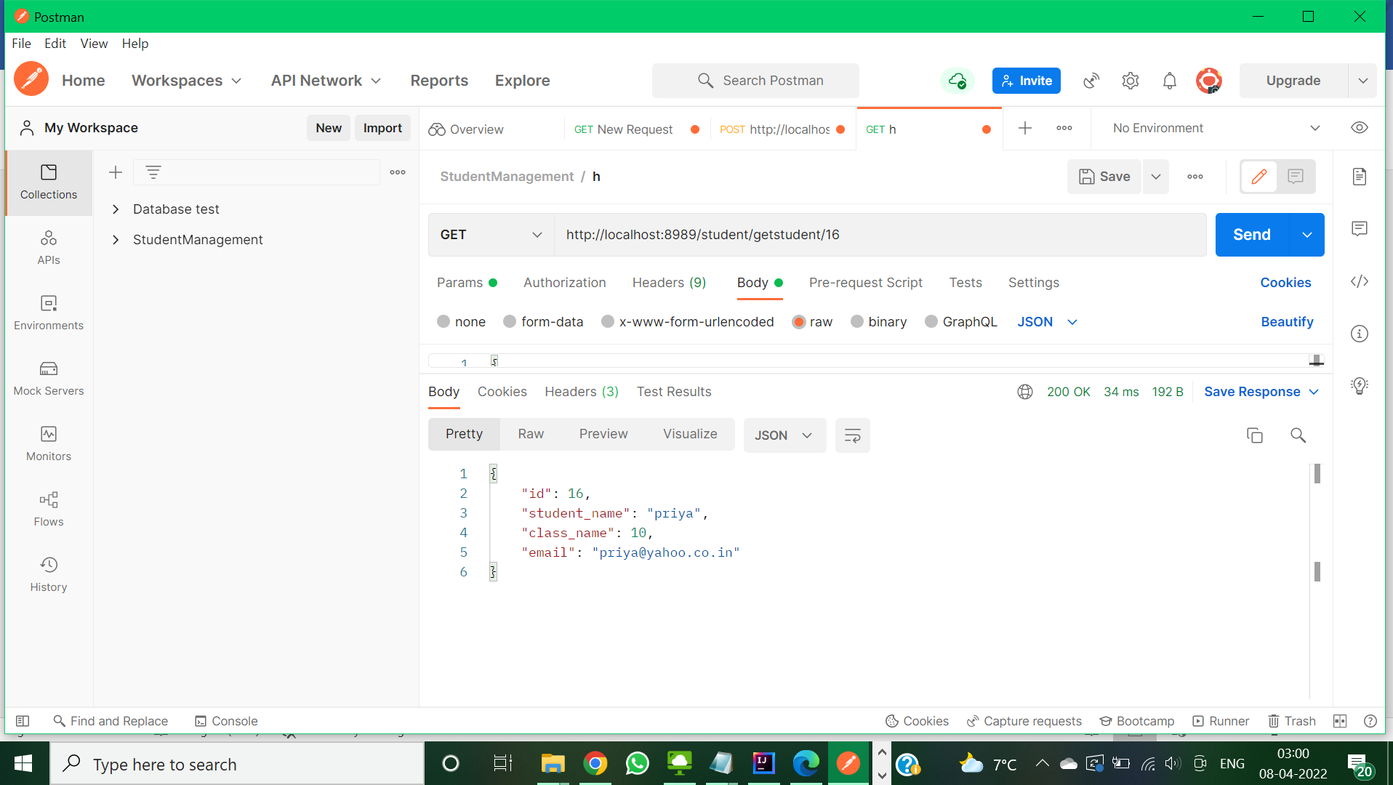

1. Using Postman accessing the student management service which inturn call fee management service to return the fee details of student through api gateway URL.

